Aim: To perform statistical analysis and hypothesis testing using the Z-Test on a dataset in python

Software Required
- Python 3.x
- Jupyter Notebook
- Libraries: pandas, numpy, scikit-learn, matplotlib

Q1. What is Hypothesis Testing?
Hypothesis testing is a statistical method used to make decisions about a population based on sample data by testing an assumption (null hypothesis) against an alternative.
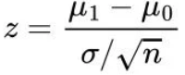
Hypothesis testing compares two opposite ideas about a group of people or things and uses data from a small part of that group (a sample) to decide which idea is more likely true.

Q2. What is Z-Test?
A Z-test is a type of hypothesis test that compares the sample’s average to the population’s average and calculates the Z-score and tells us how much the sample average is different from the population average by looking at how much the data normally varies.
The first step in a Z-test is to state the null hypothesis, H_0.
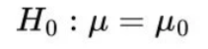
This is what you believe to be true from the population, which could be the mean of the population, μ_0:

Next, state the alternate hypothesis, H_1.
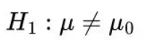
This is what you observe from your sample. If the sample mean is different from the population’s mean, then we say the mean is not equal to μ_0:

Q3. What is Train-Test Split?
Train-test split is a crucial machine learning technique that divides a dataset into two distinct subsets—typically 70-80% for training and 20-30% for testing—to evaluate a model's performance on unseen data.

Q4. Perform a Z-test on a game dataset to evaluate the following hypotheses:
- H₀: The mean sales of Action-Adventure games equals the overall mean sales
- H₁: The mean sales of Action-Adventure games is greater than the overall mean sales
Use a 75%–25% train-test split and interpret the results at α = 0.05.

Dataset:
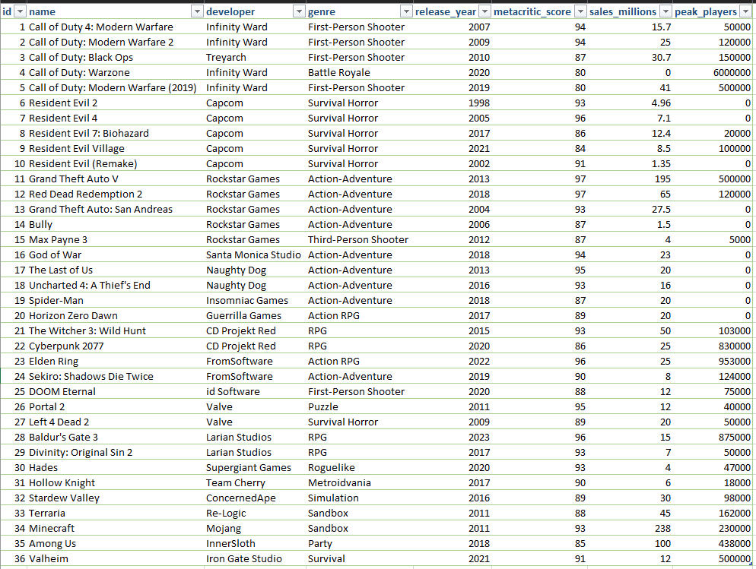
Code:
import pandas as pd
import numpy as np
from scipy.stats import norm
from sklearn.model_selection import train_test_split

data = pd.read_excel("EXP8.xlsx")

cols = ["id","name","developer","genre","release_year","metacritic_score","sales_millions","peak_players"]
df = pd.DataFrame(data, columns=cols)

df = df[df["sales_millions"] > 0]

train_df, test_df = train_test_split(df, test_size=0.25, random_state=42)

print("H0: Mean sales of Action-Adventure games = Overall mean sales")
print("H1: Mean sales of Action-Adventure games > Overall mean sales\n")

population_mean = train_df["sales_millions"].mean()

sample = train_df[train_df["genre"] == "Action-Adventure"]["sales_millions"]

sample_mean = sample.mean()
sample_std = sample.std(ddof=1)
n = len(sample)

z_score = (sample_mean - population_mean) / (sample_std / np.sqrt(n))
p_value = 1 - norm.cdf(z_score)

alpha = 0.05

print("===== TRAINING SET RESULTS =====")
print(f"Sample size (n): {n}")
print(f"Sample mean: {sample_mean:.2f}")
print(f"Population mean: {population_mean:.2f}")
print(f"Z-score: {z_score:.4f}")
print(f"P-value: {p_value:.6f}\n")

output_table = pd.DataFrame({
"value1": [round(sample_mean, 6)],
"value2": [round(population_mean, 6)],
"score": [round(z_score, 6)],
"p_value": [round(p_value, 6)],
"Hypothesis_accepted": [
"Yes" if p_value >= alpha else "No"
]
})

print(output_table.to_string(index=False))

if p_value < alpha:
print("\nDecision: Reject H0")
else:
print("\nDecision: Fail to Reject H0")

test_population_mean = test_df["sales_millions"].mean()
test_sample = test_df[test_df["genre"] == "Action-Adventure"]["sales_millions"]

if len(test_sample) > 0:
test_mean = test_sample.mean()
print("\n===== TEST SET CHECK =====")
print(f"Test sample mean: {test_mean:.2f}")
print(f"Test population mean: {test_population_mean:.2f}")

import matplotlib.pyplot as plt

train_size = len(train_df)
test_size = len(test_df)

labels = ["Training (75%)", "Testing (25%)"]
sizes = [train_size, test_size]

plt.figure()
plt.bar(labels, sizes)

plt.title("Train-Test Split (75% - 25%)")
plt.xlabel("Dataset Split")
plt.ylabel("Number of Samples")

for i, v in enumerate(sizes):
plt.text(i, v, str(v), ha='center', va='bottom')

plt.show()

Output:
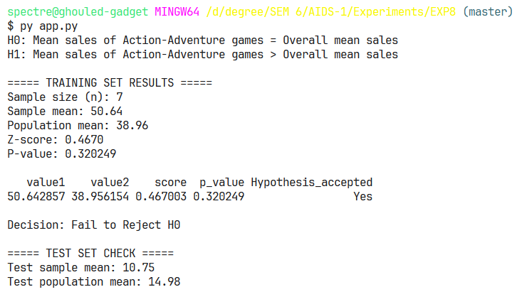
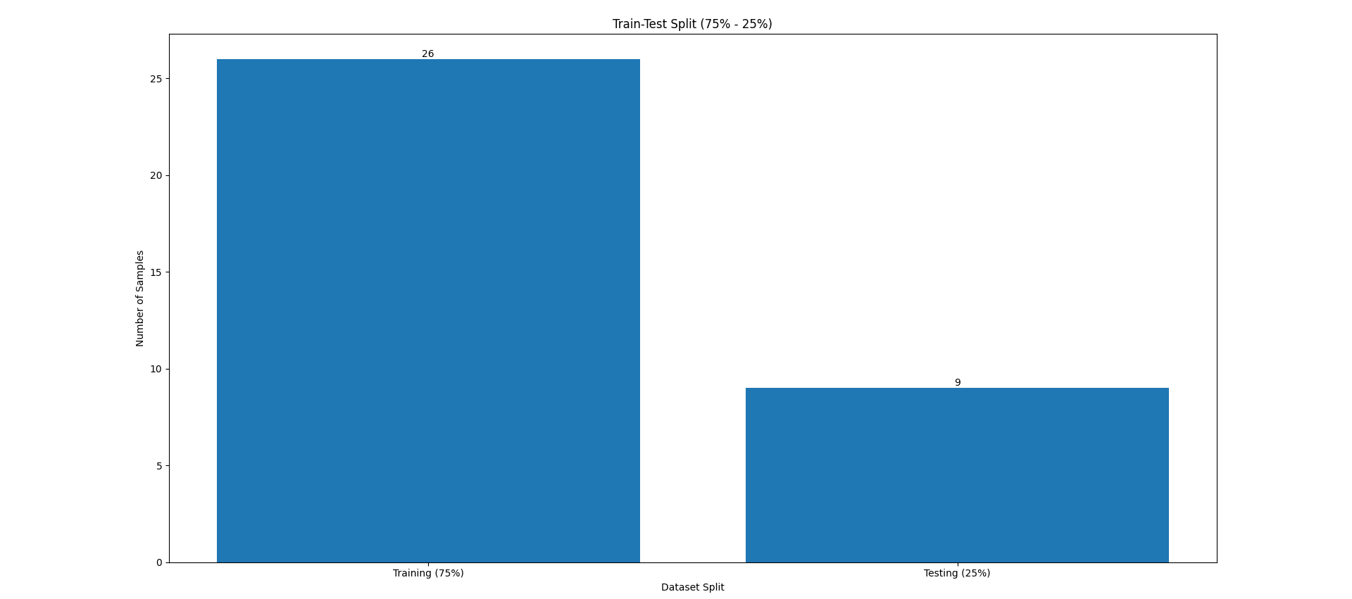

Conclusion:
Successfully applied the Z-test to evaluate hypotheses using dataset splitting, enabling statistically valid conclusions and demonstrating the role of hypothesis testing in data-driven decision-making.

